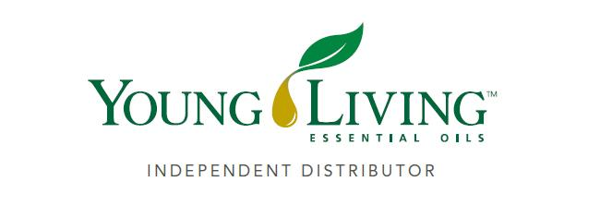
Lansing Essential Oils Newsletter
William Lansing
YL #340519
July 2022
3266 275th St, Worthington, IA 52078
563-926-2534
Lansingessentialoils.com
Lansingessentialoilsinc@gmail.com
Newsletter specific: Lansingessentialoilsnewsletter@gmail.com
We do not treat or diagnose. This newsletter is intended for informative purpose ONLY. If you have an illness or personal issue it is always best to consult your physician.

CLASSES:
Young Living Class will be held the first Thursday of every month at 6:30 PM at the Westminster Presbyterian Church- 2155 University Ave, Dubuque, IA

New Products revealed at Convention :
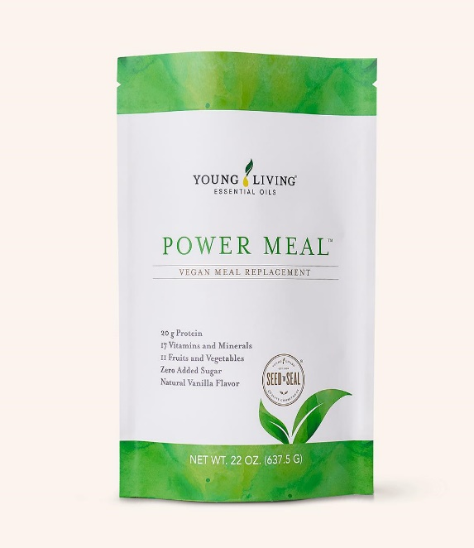
Vegan Power Meal
A nutrient-dense vegan meal replacement shake and go-to for those busy go-getters, Power Meal™ contains 20 grams of plant-based protein to keep you powering through the day. Rich in amino acids with zero added sugar, two scoops delivers 11 fruits and vegetables to fuel busy bees with a juicy dash of Orange essential oil and a light vanilla flavor. With no soy or preservatives, Power Meal lets you sip on the go without compromising your clean-living lifestyle.
Retail $72.04 Wholesale $54.75 PV 43.75
Item#40661

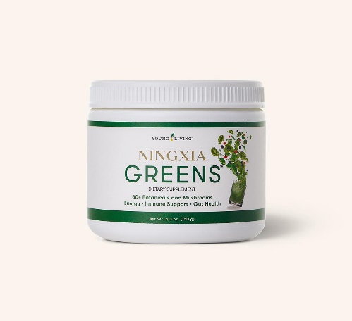
NingXia Greens
Meet our mushroom, fruit, and vegetable powder, NingXia Greens: a one-scoop solution to health and wellness.
Retail $61.51 Wholesale $46.75 PV 43.75
Item # 41064

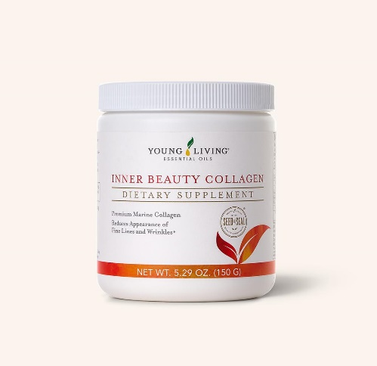
Inner Beauty Collagen
Meet Inner Beauty Collagen™. Made with 5 grams per serving of a highly soluble form of bioavailable type I marine collagen, peach ceramides, hyaluronic acid, antioxidants, and no added sugars, our filler-free formula supports your natural radiance from the inside out.
Retail $85.20 Wholesale $64.75
Item # 40578

300 PV Retail Value $187.51
Receive our Feather the owl Diffuser for free, plus Kidscents Kidpower and Kidscents Spleepzy. Place you order through Loyalty Rewards and also receive a free essential oil felt pouch, Thieves Spray and Thieves Waterless Hand Sanitizer

250 PV Retail value $113.83
Receive Kidscents Kidpower and Kidscents Slpeepylze for free. Place your qualifying order through Loyalty Rewards and you will also enjoy a free Essential Oil Felt Pouch, Thieves Spray and Thieves waterless hand sanitizer.

190 PV Retail value $34.22
Receive Kidscents Sleepylze for free. Place your order through Loyalty Rewards and you will also receive a free Essential oil felt pouch, Thieves Spray and Thieves Waterless hand sanitizer.

100 PV Retail Value $13.16
Place your qualifying order through Loyalty Rewards and receive an essential oil felt pouch for free.

Use the essential oil felt pouch to send 3 - 5ml bottles of oils with your child to school.

Lansing Essential Oils
3266 275th Street
Worthington, IA 52078
YL# 340519
July 2022
RETURN SERVICE REQUESTED

To receive future newsletters via email, please send us an email from the requesting address.
We will then add you to our email list. The email address is willylansing@gmail.com
Address Change—Please Print
Notify us via email: Lansingessentialoilsnewsletter@gmail.com, phone: 563-926-2534,
or mail: 3266 275th St. Worthington, IA 52078
Name:__________________________________________________________________
Address:________________________________________________________________
City:________________________________________State:____________Zip:_______
Email:__________________________________________________________________
If you have a change of address or Email please let Young Living know so they can update your information also.

