
Lansing Essential Oils Newsletter
William Lansing
YL #340519
September 2022
3266 275th St, Worthington, IA 52078
563-926-2534
Lansingessentialoils.com
Lansingessentialoilsinc@gmail.com
Newsletter specific: Lansingessentialoilsnewsletter@gmail.com
We do not treat or diagnose. This newsletter is intended for informative purpose ONLY. If you have an illness or personal issue it is always best to consult your physician.

CLASSES:
Young Living Class will be held the first Thursday of every month at 6:30 PM at the Westminster Presbyterian Church- 2155 University Ave, Dubuque, IA

Grand Opening September 5th for Sadie Sawvell’s raindrop therapy at Prairie Camper Sales 1834 S Marquette Rd Prairie Du Chien WI. Her phone number is 608-306-0381 and her email is hhwellnesscare@gmail.com. She is doing raindrop for Equine also.

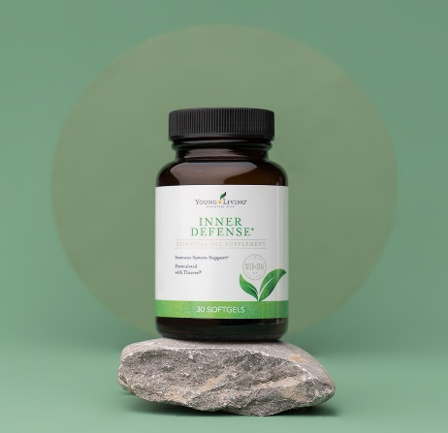
Spend 300 PV Retail Value $214.14
Inner Defense #3295-Your body is hard at work to keep you healthy and strong. Give your germ fighters extra support with Inner Defense! Keep a bottle in your bag and take one capsule 3-5 times a day to arm your healthy immune system with added support. You also get Kidscents SniffleEase Essential Oil Blend 5ml, Breathe Again Essential Oil Blend 15ml and 10 Loyalty
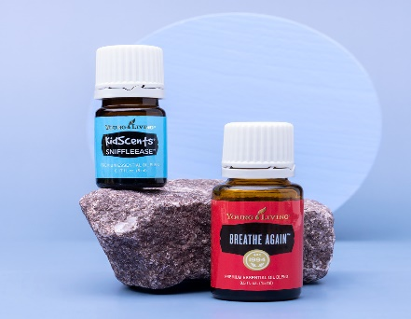
Points,Thieves Essential oil Blend 15ml and R.C. Essential oil Blend 15ml.

Spend 250 PV Retail Value $173.68

Get Breathe Again Essential Oil Blend 15ml and Kidscents SniffleEase Essential Oil Blend 5ml. Add a few drops of Breathe Again to your diffuser before bed and enjoy the feeling of fuller, deep breaths with a natural cooling sensation form this blend of Copaiba, Myrtle, Peppermint and more.
Kidscents SniffleEase essential oil blend saves the day with a relaxing, quieting aroma that’s cool to the touch. Also receive R.C. Essential oil 15ml Loyalty points and Thieves essential oil Blend 15ml.

Spend 190 PV Retail Value $117.44- Get R.C. Essential Oil Blend 15ml. Clear the way with R.C. Keep a bottle with you and gently massage a few drops onto your back and chest for extra relief when things are feeling cloudy. Also get Thieves Essential oil blend 15ml-It’s a perfect all-natural perfume that provides purifying properties while leaving everyone asking, “What are you wearing?” with spicy Clove, Cinnamon Bark, and a dash of Lemon. Also includes Loyalty points.

Spend 100 PV Retail value $13.16 and get 10 loyalty points.
It’s the Simplified By Jacob+Kait Fall Collection
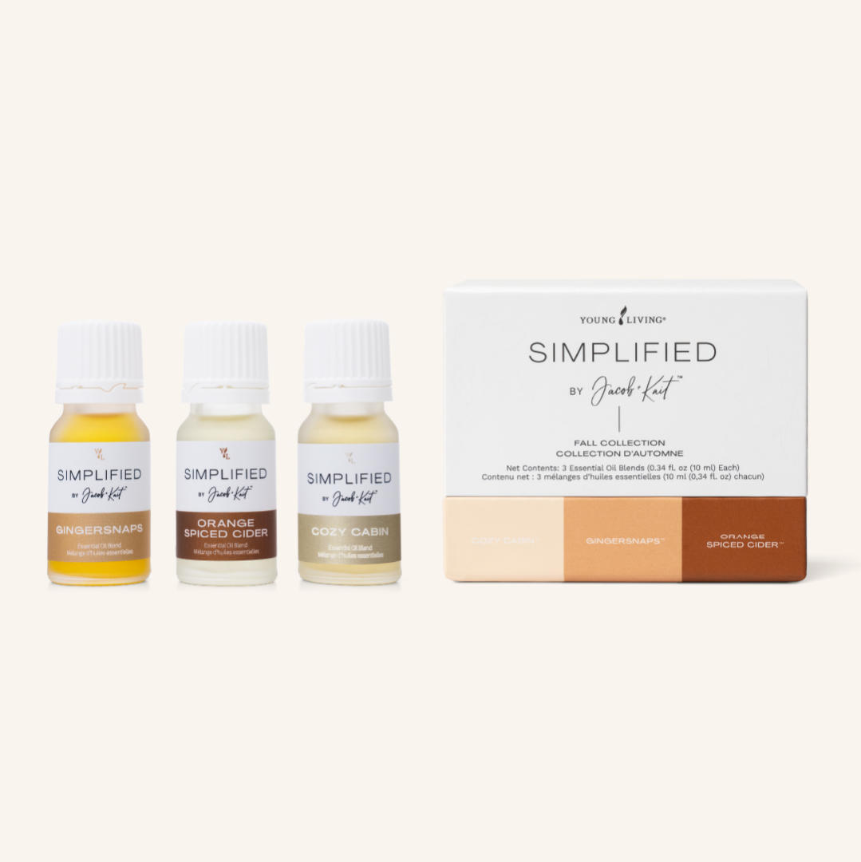

Curl up with these three cozy fall essential oil blends inspired by comforting memories of crisp autumn days. It’s the Simplified By Jacob+Kait- Fall Collection.
Simplified by Jacob + Kait™ is a line of essential oil blends created just for the smell of it. Brought to you by Jacob and Kaitlyn Young in partnership with the D. Gary Young Research Institute, the Fall Collection comes with three limited-time scents for the coziest time of year. Between apple picking and leaf peeping, make the most of the crisp autumn days with Cozy Cabin, Gingersnaps, and Orange Spiced Cider.
While many fall-scented candles and air fresheners contain harmful chemicals that can pollute your home, these blends are made exclusively with good, clean ingredients straight from nature.
Snag all three fall scents today!

2022 Glamping Beauty School
September 29- October 1,2022
Naples, ID

Take a vacation from the everyday and opt for the extraordinary-Glamping Beauty School. Pamper yourself with clean beauty and learn how to achieve it with tutorials and presentations that can change your life. From product essentials to immersive instruction, you will learn how to create your skincare and beauty routines and appreciate your authentic beauty. Come glamping with us at the picturesque Highland Flats Tree Farm to understand more about Young Living’s natural beauty and surround yourself with the amazing essence for Grand Fir, Blue Spruce and Pine. Escape to a better you and get your ticket today!

Unforgettable Experience
- Participate in YL’s Seed to Seal® at one of the world’s largest essential oil distilleries, and take home your own farm oil (Evergreen Essence Oil)
- Activities unique to the Glamping Beauty School
  - Themed days with exciting takeaways
  - Breathe in the fresh air and aroma of blue spruce, balsam fir, and pine trees
  - Optional tour to St. Maries Farm, where it all started
Your $300 ticket includes
- Registration kit with sample and full-size products, Amoressence™ essential oil blend, swag, training instruction, and more
- Lunch and dinner on the farm on September 29 and 30th, including a bag lunch on October 1st
- Nutrition, lifestyle, and personal improvement classes taught by industry experts
- Beauty Boutique, featuring product sampling, unique business-building tools, shopping and creative sharing ideas
- Product store with an additional 10 percent discount
- Facial Photo (value $15.00)
- Attendance certificate
- Optional activities:
- • Raindrop Technique Class: $100 (September 28)
- Includes a raindrop registration kit and lunch
- • Optional stay (overnight) on the Highland Flats Tree Farm (limited spots)
- Breakfast included
- - $75.00 per bed/per night (5-6 people in the room)
- $90.00 per bed/per night (2 people in the room)
- • Optional field trip to St. Maries Lavender Farm (October 1)
- $30 Bus and Lunch
- $15 Lunch Only
- *Raindrop Technique Massage: $120
- The registration for the Raindrop Massage will be offered when you arrive at the farm. Please sign up for all other optional activities (including the reservation to stay on the farm overnight), through the cvent registration page.

Diffuser Blends

Immune Booster
5 drops Thieves essential oil
3 Drops Frankincense essential oil

Seasonal Symptoms
3 drops Peppermint essential oil
3 Drops Lavender essential oil
3 drops Lemon essential oil

Breathe Easy
4 drops R.C. essential oil
4 drops Lemon essential oil

Sweet Dreams
4 drops Lavender essential oil
4 drops Stress Away essential oil

Rise ‘n Shine
4 drops Lemon essential oil
4 drops Peppermint essential oil

Happy Days
4 drops Stress Away essential oil
4 drops Orange essential oil

Stink Away
5 drops Purification essential oil
3 drops Orange essential oil

