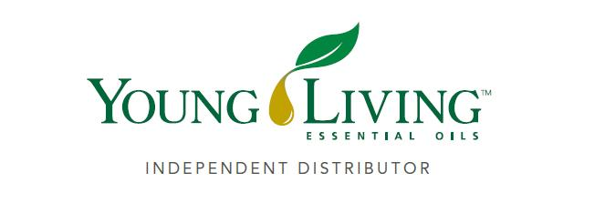
Lansing Essential Oils Newsletter
William Lansing
YL #340519
October 2022
3266 275th St, Worthington, IA 52078
563-926-2534
Lansingessentialoils.com
Lansingessentialoilsinc@gmail.com
Newsletter specific: Lansingessentialoilsnewsletter@gmail.com
We do not treat or diagnose. This newsletter is intended for informative purpose ONLY. If you have an illness or personal issue it is always best to consult your physician.

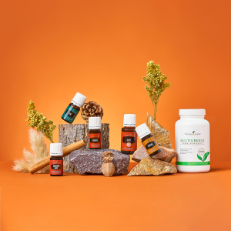

Get swept up by fall scents with October’s gift with purchase
Take yourself back to childhood memories of pumpkin patches and cozy autumn nights with October’s gift with purchase. Stay cozy with familiar fall scents, including Cinnamon Bark, Pine, Nutmeg, Clove, and Copaiba essential oils. Plus, give your body a little boost with MultiGreens™ capsules!

Young Living’s monthly gift with purchase allows you to earn rewards just for shopping your favorite essential oils and oil-infused products. Purchase products with a point value (PV)—these products help you qualify for this month’s gifts. The more you shop, the more you earn!
Spend 300PV: You will get MultiGreens Capsules 120ct., 10 Loyalty Points, Cinnamon Bark essential oil 5ml, Pine essential oil 5ml and Nutmeg essential oil 5ml.
Spend 250PV: You will get Clove essential oil 15ml, Copaiba essential oil 5ml plus 10 loyalty points, Cinnamon Bark, Pine and Nutmeg essential oils.
Spend 190PV: Receive 10 loyalty points plus Pine Cinnamon Bark and Nutmeg essential oils.
Spend 100 PV: Receive 10 Loyalty points

MultiGreens Capsules 120ct

Harness the power of plants with MultiGreens capsules, a proprietary blend of powdered greens like spirulina and barley grass plus bee pollen that’s infused with essential oils to keep you going strong in the breezy autumn months.

Cinnamon Bark Essential Oil 5ml

The ultimate scent of the season Cinnamon Bark has a warm, spicy aroma that reminds you of days curled up next to the fire.
Dilute this oil and then apply it to tired muscles for a deep, relaxing massage.

Pine Essential Oil 5 ml

A fresh, woodsy aroma, Pine E. O. captures the essence of the forest to help you stay grounded as the seasons change. Diffuse it during meditation to bring yourself back to a calm, natural state or add a few diluted drops to your skin before venturing into the woods to enjoy your hike annoyance free.

Nutmeg® Essential Oil 5 ml

As the weather cools down, Nutmeg is here to bring you comfort and keep you cozy when the summer leaves turn to autumn colors. A warm and spicy scent, Nutmeg’s aroma energizes & uplifts, creating a refreshing breathing experience when applied topically—just remember to dilute!

Clove Essential Oil 15ml

Add some spice to your day with Clove essential oil. Add a few extra drops to your spray bottle of our Thieves Household cleaner it helps to gently lift dirt and grime while leaving behind a spicy, refreshing scent.

Copaiba Essential Oil 5ml

Keep that summer glow! Copaiba is known for supporting the appearance of youthful skin. You can dilute it or add it to your moisturizer and gently massage it into your skin for a luxe, spa-like experience.

CLASSES:
Young Living Class will be held the first Thursday of every month at 6:30 PM at the Westminster Presbyterian Church- 2155 University Ave, Dubuque, IA

Apple Cupcakes

2 pre-made, ready to roll pie crusts or homemade All Butter Pie Crust

Apple Pie Filling:
2 Tablespoons unsalted butter
2 large apples, peeled, cored and diced into ¼ inch cubes
2 Tablespoons brown sugar
½ teaspoon cinnamon or (3 drops Cinnamon Bark essential oil)
1/8 teaspoon salt
2 Tablespoons lemon juice

Crisp Topping:
¼ cup all purpose flour
¼ cup oatmeal
¼ cup brown sugar
½ tsp. cinnamon (3 drops Cinnamon Bark essential oil
2 Tbsp. coconut oil
Whipped cream, ice cream or caramel sauce for topping

Instructions:

Heat oven to 350 degrees.

Lightly spray 24 mini muffin cups with cooking spray.

In a medium saucepan melt butter, add apples, brown sugar, salt and cinnamon. Cook over medium-high heat stirring often until apples are tender, about 10-12 minutes.
Stir in lemon juice and set pan aside to cool.

In a medium bowl combine flour, brown sugar and oatmeal, add butter and mix in until crumbly.

Roll the pie crust out on a floured surface with a floured rolling pin.
Using a round cookie or biscuit cutter ( approximately 3 inches in diameter) cut at least 24 rounds out (12 rounds of each pie crust if using store bought)

Carefully press each round into the mini muffin pan.
Using your fingers to round the ends into a pie crust.
Brush egg wash to the top edges of each cupcake.
Divide the apple filling evenly onto pie crusts in muffin cups then top with the crumble topping.

Bake for 15-20 minutes or until golden brown around the edges.
Remove from oven and let cool on a cooling rack.
Once cooled, use the tip of a knife to loosen the crusts from the mini muffin cups.

Serve the cupcakes topped with whipped cream, with ice cream or topped with a drizzle of caramel sauce.
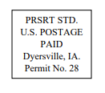
Lansing Essential Oils
3266 275th Street
Worthington, IA 52078
YL# 340519
August 2022
RETURN SERVICE REQUESTED

To receive future newsletters via email, please send us an email from the requesting address.
We will then add you to our email list. The email address is willylansing@gmail.com
Address Change—Please Print
Notify us via email: Lansingessentialoilsnewsletter@gmail.com, phone: 563-926-2534,
or mail: 3266 275th St. Worthington, IA 52078
Name: __________________________________________________________________
Address: ________________________________________________________________
City: ________________________________________State: ____________Zip: _______
Email: __________________________________________________________________ If you have a change of address or Email, please let Young Living know so they can update your information also.

