 Lansing Essential Oils Newsletter
William Lansing
YL #340519
December 2022
3266 275th St, Worthington, IA 52078
563-926-2534
Lansingessentialoils.com
Lansingessentialoilsinc@gmail.com
Newsletter specific: Lansingessentialoilsnewsletter@gmail.com
We do not treat or diagnose. This newsletter is intended for informative purpose ONLY. If you have an illness or personal issue it is always best to consult your physician.

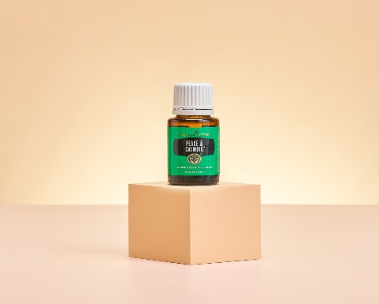
Spend 300PV
Get Peace & Calming 15ml., Thieves Wipes, Thieves Cleansing Soap, 10 Loyalty points and Loyalty orders get Valor essential oil 5ml and 10 loyalty points.

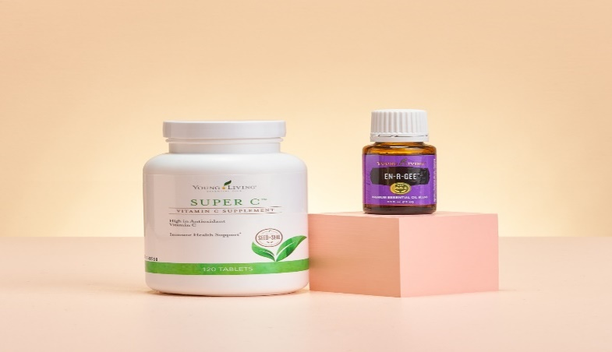
Spend 250PV
Get Super C tablets, En-R-Gee essential oil 15ml. Thieves wipes, Thieves cleansing soap,
Loyalty orders ger Valor essential oil 5ml and 10 Loyalty points.
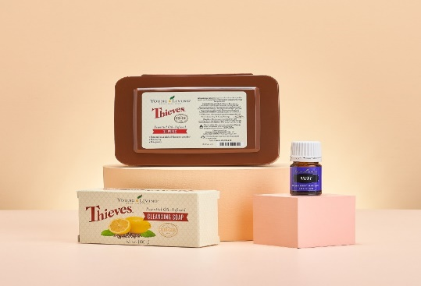
Spend 190PV
Get Thieves cleansing soap, Thieves Wipes and Loyalty orders get Valor essential oil 5 ml and 10 Loyalty points.

CLASSES:
Young Living Class will be held the first Thursday of every month at 6:30 PM at the Westminster Presbyterian Church- 2155 University Ave, Dubuque, IA

NEW PRODUCTS: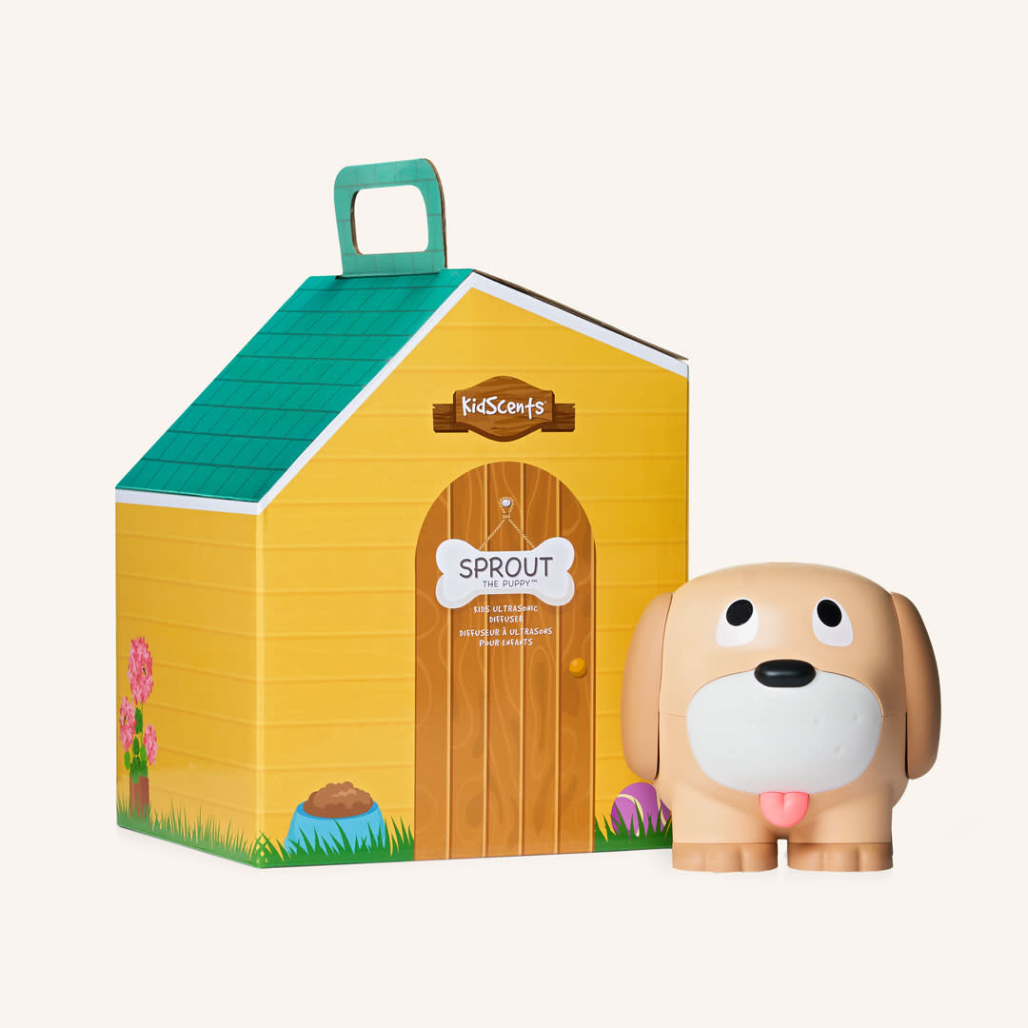
Say Hello to Sprout The Puppy Young Living’s new Diffuser. It comes with everything you need to get started, including a 15ml bottle of Kidscents Kid Power blend and a 5 ml bottle of Sleepylze blend.
Retail $130.26 Wholesale $99.00
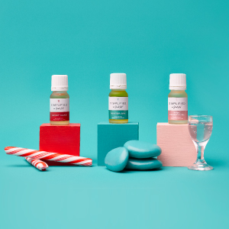
Make your home smell festive and fresh with the new Simplified by Jacob + Kait™ Winter Collection. Featuring Candy Cane™, Winter Spa™, and Pink Champagne™ essential oil blends, this limited-time collection transforms your space into a holiday haven anytime, anywhere. Get it now on a one-time or loyalty order before it’s gone!
Retail $ 131.58 Wholesale $100.00

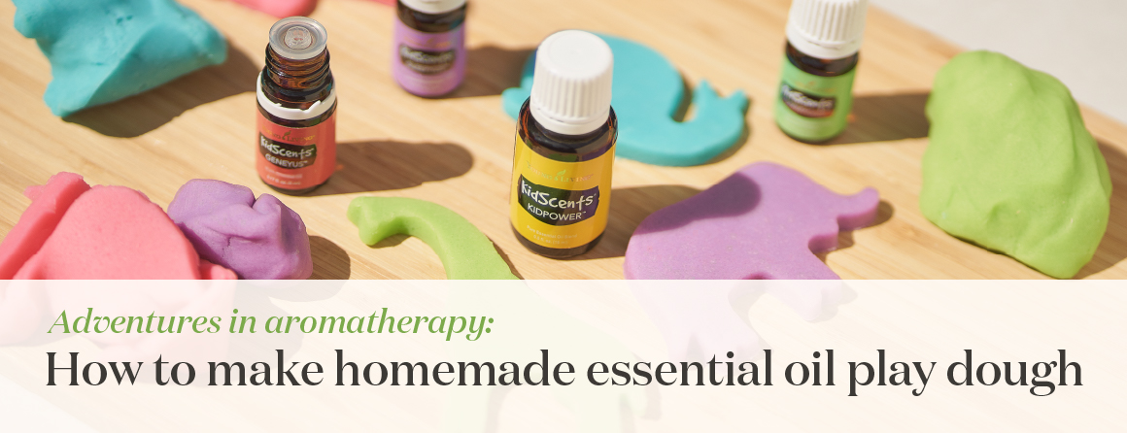
Essential oil play dough combines aromatherapy, color, and creativity! Switch out that stale, store-bought dough for this easy recipe that uses simple ingredients lying around your pantry. Watch your children’s imaginations soar as they pick their favorite color and scent combos and enjoy stimulating multisensory play. This DIY play dough is quick and easy and ties up your youngsters for hours of safe, fragrant fun.

Ingredients you’ll need:
2½ cups water
2½ tablespoons olive oil
2½ cups all-purpose flour
1¼ cup salt
5 teaspoons cream of tartar
5–10 drops essential oil
Natural food coloring (You can use liquid or powder coloring. Adjust the amount to your desired color.)
These measurements will make enough dough for 4–6 colors. Double the recipe if you want more!

How to make essential oil play dough
1. Place the water and olive oil into a medium pot on the stove. Simmer on medium heat while you prepare your dry ingredients.
2. In a separate bowl, combine flour, salt, and cream of tartar. Whisk until incorporated.

3. Add half of the dry mixture into the pot with your water and oil. Whisk for 5 seconds to incorporate, then add the second half of the dry mixture into the pot.
4. Whisk continuously on medium heat until the mixture is smooth and lump free, about 15–30 seconds.
5. Once the mixture becomes slightly thicker, switch to using a wooden spoon or silicone spatula to continue to stir and knead it. Keep stirring to avoid burning the dough. Be patient. The mix will take around 2–3 minutes of constant stirring and kneading until it takes on a play dough-like consistency.
6. Once you have a thick, doughy consistency, remove the dough from the pot and place it onto a clean surface.
7. Let cool for 5 minutes, then knead the dough for 1 minute.
8. Split into 4–6 equal pieces.
9. Add your coloring and essential oils to one piece at a time, then knead until fully incorporated. Repeat with different colors and oils in the other sections of dough. Wear gloves during this step to avoid staining your hands.
10. Bring on the fun!
YL tip: Let your children help with the steps that are appropriate for their age. This will make the DIY activity feel even more special and fun.
YL tip: You don’t have to stick to just one scent: Kids love to experiment, so encourage them to combine their favorites for creative, delicious-smelling blends..
Feel free to customize the colors and oils to fit your children’s preferences and aromatherapy needs. The combos and benefits are endless! Before your kids unwind for the afternoon, let them play with Lavender-infused play dough. For an aroma that inspires your children with confidence and positivity, infuse your play dough with KidScents KidPower.
Enhance the fun by adding tools that your kids can use to make play dough time even more fun. You could bring in simple items like cookie cutters, child-friendly scissors, or a rolling pin or challenge each other by creating shapes and figures out of the dough and guessing what they are.
How to store your play dough
After your kiddos are done playing for the day, simply store your play dough in airtight containers in the fridge. The dough should last at least three months when stored correctly. If it starts to get dry after excessive playing, try adding 1 drop of essential oil or a few drops of water to add back some moisture.

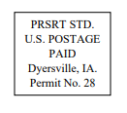
Lansing Essential Oils
3266 275th Street
Worthington, IA 52078
YL# 340519
December 2022
RETURN SERVICE REQUESTED

To receive future newsletters via email, please send us an email from the requesting address.
We will then add you to our email list. The email address is willylansing@gmail.com
Address Change—Please Print
Notify us via email: Lansingessentialoilsnewsletter@gmail.com, phone: 563-926-2534,
or mail: 3266 275th St. Worthington, IA 52078
Name: __________________________________________________________________
Address: ________________________________________________________________
City: ________________________________________State: ____________Zip: _______
Email: __________________________________________________________________ If you have a change of address or Email, please let Young Living know so they can update your information also.

