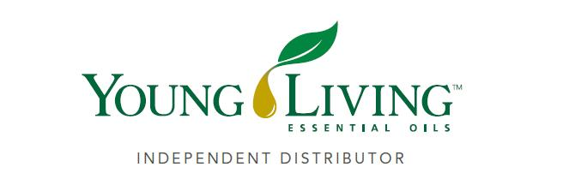Lansing Essential Oils Newsletter
William Lansing
YL #340519
January 2023
3266 275th St, Worthington, IA 52078
563-926-2534
Lansingessentialoils.com
Lansingessentialoilsinc@gmail.com
Newsletter specific: Lansingessentialoilsnewsletter@gmail.com
We do not treat or diagnose. This newsletter is intended for informative purpose ONLY. If you have an illness or personal issue it is always best to consult your physician.

We hope everyone had a very Merry Christmas. May your 2023 be a very prosperous year

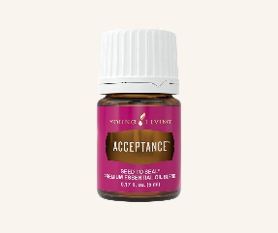
Acceptance - is a blend of 19 essential oils that encourages feelings of self-worth and inspires you to break through personal barriers and rest negative and emotional thought patterns.
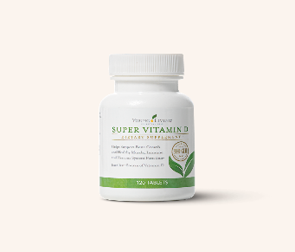

Super Vitamin D – Have one of these fruity, easy-disslove tablets each day to help support a healthy immune system.

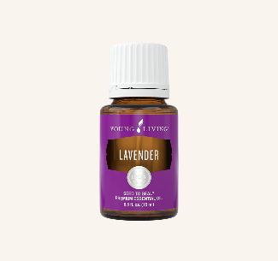
Lavender – Reach for Lavender, your relaxing gym or wind-down companion, and create a tranquil environment at home of on the go.
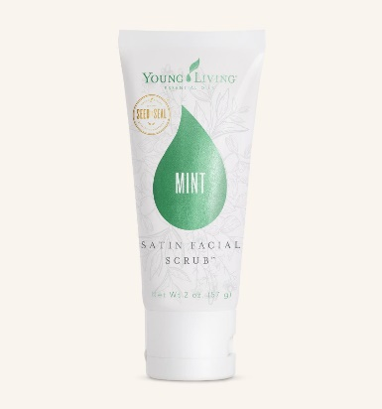
Satin Facial Scrub – is made with apricot seed powder and Peppermint premium essential oil to gently exfoliate and invigorate skin. Start or end your day with a moment just for you. This gentle exfoliant invigorates the skin and brightens the appearance of your complexion, leaving you with the look of an even skin tone.

Spend 300PV

Receive - Acceptance 5ml, Lavender 15ml, Super Vitamin D tablets 120 ct, Satin Facial Scrub, Mint, 2 oz. and 10 Loyalty points.
Spend 250PV
Receive – Lavender 15ml, Super Vitamin D tablets 120 ct, Satin Facial Scrub Mint 2 oz and 10 Loyalty points.

Spend 190 PV
Receive – Lavender 15ml, Super Vitamin D tablets 120 ct, and 10 Loyalty points.

Spend 100 PV
Receive 10 Loyalty points.

The Lucious lavender plant is a member of the mint family and is originally native to the Mediterranean, Young Living helps this plant flourish at the Young Living Lavender Farm and Distillery in Mona, Utah: the St. Maries Lavender Farm and Distillery in St. Maries, Idaho and the Simiane-la-Rotonde Lavender Farm and Distillery in Simiane-La-Rotonde, France. It takes about 27 square feet of lavender plants to create just one 15ml bottle of lavender essential oil, so these farms are busy year round.

Best ways to use Lavender essential oil –
- Diffuse at bedtime. Just add a few drops to a diffuser and let it run for a few minutes as part of your bedtime routine. Enjoying the calming familiar scent is a dreamy way to drift off. Depending on your affinity for the scent of Lavender oil, you can even put a few drops on a tissue or cotton ball and tuck it in your pillowcase for consistent aroma.
- Apply for glowing skin. This oil hs been traditionally used for cleansing and soothing skin. Add Lavender essential oil to your favorite lotion or hair care products to support healthy looking skin and calp and for a boost of floral aroma. It can be added to your daily face wash routine to soothe minor skin irritations, plus the aroma will help keep you alert.
- 3. Create a calm environment. If you are feeling overwhelmed use this oil to calm you when life gets busy. Diffuse while you take a few minutes to breathe deeply, enjoy the aroma and recite calming affirmations.
- Soothe skin after a day in the sun. Soothe your skin with Young Living LavaDerm After -Sun Spray, which features Lavender essential oil as a primary ingredient.
- Add a sweet floral aroma to any DIY project. Making bath bombs, linen spray your own perfume or cleaning fizzies? Lavender is the scent your DIY projects have been dreaming of for exquisite floral aroma.
- Take hair care up a notch. Ensure a good hair day every day with a drop or two pf Lavender oil mixed with Rosemary essential oil in your shampoo. Your healthier looking hair will catch everyone’s eye.
- Support a healthier looking complexion. Embrace the years as they go by and add Lavender essential oil to your moisturizer to support our skin.
- Boost your favorite drinks. You know what we might like even more than the smell of Lavender is the taste. Add a splas of elegance to your lemonade with Lavender Vitality essential oil.
- Promote tranquility. When applied topically through massage.
- Level up your cooking. Lavender Vitality oil is a great way to add new flavor to your favorite recipes.

Lavender Hot Cocoa

- 4 cups unsweetened almond, dairy, or other milk of your choice
- 8 tablespoons unsweetened cocoa
- 1 teaspoon vanilla extract
- 4 teaspoons honey, or more to taste
- 4 drops Lavender Vitality essential oil

Instructions
- Heat 4 cups of milk in a saucepan on medium-high heat.
- Add 8 tablespoons unsweetened raw cocoa, 1 teaspoon vanilla extract, and 4 teaspoons honey; whisk until smooth.
- When warm, remove from heat and stir in 4 drops Lavender Vitality essential oil.
Serve and enjoy!

Here are a few simple Relaxing Blend recipes to diffuse
Get your Chill on Sweet Sleep
5 Drops Lavender 3 drops Lavender 2 drops Spearmint
5 Drops Copaiba 2 drops Tangerine 1 drop Ylang Ylang

