250 P.V. Retail value: $127.13

• Myrrh essential oil, 5 ml
• Gratitude™ essential oil blend, 5 ml
• Bonus Subscribe to Save: Gathering™ essential oil blend, 5 ml
• Bonus Subscribe to Save: Car air fresheners, 3 pk.

• Gratitude™ essential oil blend, 5 ml

• Bonus Subscribe to Save: Gathering™ essential oil blend, 5 ml
• Bonus Subscribe to Save: Car air fresheners, 3 pk.
﻿
• Free shipping

190 P.V. Retail value: $90.62

Gratitude™ essential oil blend, 5 ml

• Bonus Subscribe to Save: Gathering™ essential oil blend, 5 ml

• Bonus Subscribe to Save: Car air fresheners, 3 pk.

• Free shipping

100 P.V.• Free shipping

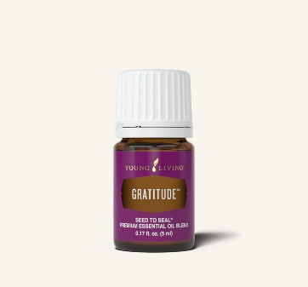
Gratitude essential oil blend, 5 ml

Gratitude™ essential oil blend contains nine essential oils and has a spiritual aroma that promotes gratitude, thankfulness, and appreciation, helping foster a positive attitude and attracting all that is good in your life.

SUGGESTED USES
- Diffuse this uplifting aroma while inviting feelings of emotional and spiritual progress.
- Use it during meditation, yoga, or personal spiritual practice while you uplift and elevate your feelings of gratitude.
- Apply 1−3 drops topically behind the ears, over the heart, on wrists, back of neck, and base of spine.

Diffuse while beginning your day with an open, uplifting mindset of appreciation.

Item # 3346 Retail $36.84 Wholesale $28.00 PV 28

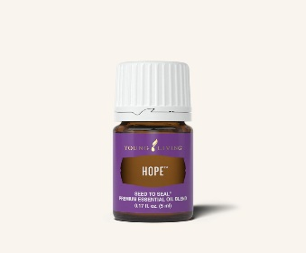
Hope essential oil blend, 5 ml
﻿
Connect to calm. Apply Hope topically during a meditation session for an uplifting atmosphere.

Hope is a spiritual blend of Melissa, Juniper, Myrrh, and Black Spruce that helps reconnect you to feelings of strength and stability toward your compelling future.

SUGGESTED USES
- Apply 1−3 drops topically when you are overwhelmed by feelings of hopelessness, doubt, or fear.
- Diffuse 8−12 drops during personal prayer or meditation.
- Apply 1−3 drops to the outside of the ears after receiving the Raindrop Technique®.
- Add it to your bath mixed with Epsom salt.

Item #3357 Retail $80.26 Wholesale $61.00 PV 61

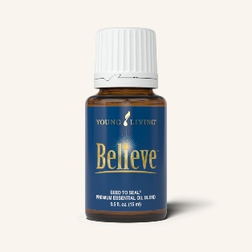
Believe essential oil blend, 5 ml

Set your sights high. Diffuse Believe as you create a vision board with all your dreams and goals.

Believe™ essential oil blend is a combination of Idaho Grand Fir, Coriander, Bergamot, Frankincense, Idaho Blue Spruce, Ylang Ylang, and Geranium that may encourage feelings of faith, inner strength, and vitality when used aromatically or applied topically during times of self-reflection and self-belief.

SUGGESTED USES
- Diffuse Believe while working on inner awareness and self-belief.
- Use it during times of self-reflection and overcoming self-doubt or inadequacy.
- Diffuse or apply it topically to enjoy the peaceful, relaxing aroma.
- Add Believe to YL's Car Vent Diffuser for a peaceful, pleasant commute.
- Inhale it for an aroma that evokes feelings of walking in the woods and helps you reconnect to nature.
- Diffuse Believe during your daily positive affirmations to encourage feelings of self-belief and confidence.

Item #4661 Retail $52.63 Wholesale $40.00 PV 40
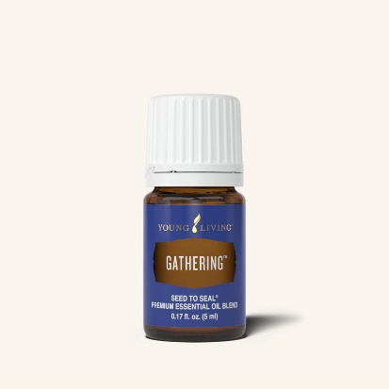
Gathering™ essential oil blend, 5 ml

Gathering™ essential oil blend is a combination of nine essential oils that creates an aroma to gather like-minded people together on a physical, emotional, mental, social, and spiritual level, allowing you to rise above the chaotic energies of the world today and find a place of spiritual peace.

SUGGESTED USES
- Diffuse 8−12 drops for a harmonizing environment.
- Add Gathering to your bath with Epsom salt.
- Use it during meditation, yoga, or prayer to enjoy the supportive and balancing aroma.
- Apply 1−3 drops topically during life’s challenges and trials.
- Apply 1−3 drops to the heart while you work on gathering strength and wisdom from within.
- Diffuse this uplifting aroma during small or large gatherings.
Item #3342 Retail $41.78 Wholesale $31.75 PV 31.75

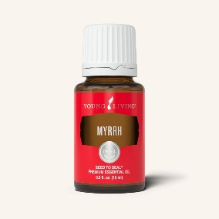
Myrrh essential oil, 5 ml

Myrrh essential oil beautifies, cleanses, and moisturizes the skin, making it a great addition to your skin care routine. In addition, its sweet, earthy aroma can be used to enhance yoga, meditation, and spiritual practices.

SUGGESTED USES
- Diffuse for spiritual awareness and reflection
- Combine this earthy and uplifting aroma with Frankincense to create a meditative environment
- Add to your favorite skincare products
- Add to Thieves dental hygiene products to maintain oral health (toothpaste, mouthwash, floss)

Item # 3593 Retail $91.45 Wholesale $69.50 PV 69.50

Car air fresheners, 3 pk.
• Create good vibes on the go. Make errand runs a little more fun with these oil-ready air fresheners.
﻿• Diffuse the tension. Distract your kids from backseat roughhousing with your favorite Young Living blends in car air fresheners

NOTE: Just to let you know with winter months coming be sure to order your Ninxgia Red ahead so it doesn’t freeze on you.



