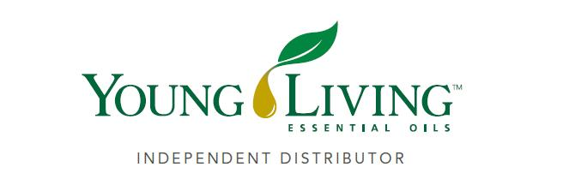
Lansing Essential Oils Newsletter
William Lansing
YL #340519
January 2022
3266 275th St, Worthington, IA 52078
563-926-2534
Lansingessentialoils.com
Lansingessentialoilsinc@gmail.com
Newsletter specific: Lansingessentialoilsnewsletter@gmail.com
We do not treat or diagnose. This newsletter is intended for informative purpose ONLY. If you have an illness or personal issue it is always best to consult your physician.


Energize your new year with this month’s rewards! 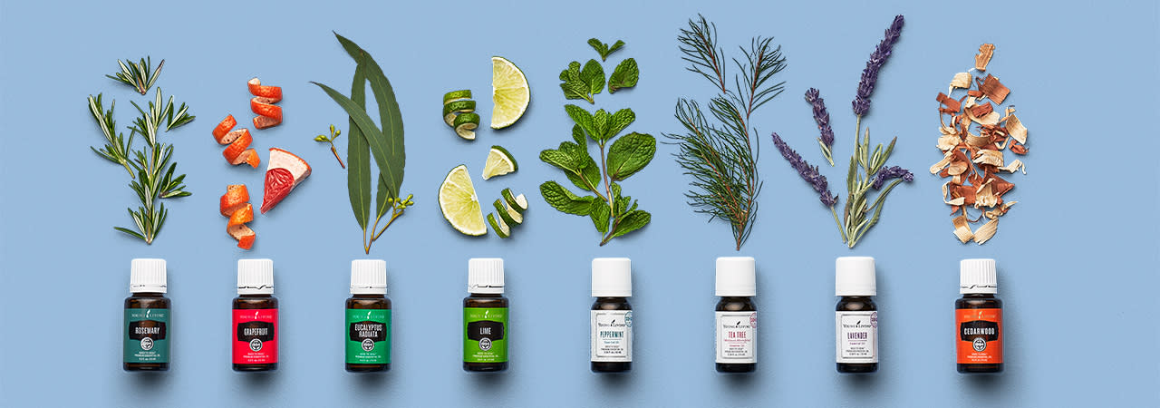
Spend 250 PV

Retail value: $88.82+ free shipping
Lime essential oil, 15 ml
Add some zest to your day and take a mini tropical staycation in a bottle! Invite Lime’s sunny, citrusy notes into your favorite spaces by diffusing it or add it to your DIY cleaner to enjoy its fresh, clean scent.
What’s a vacation without some spa time? Give your skin some glow by applying 2 drops of Lime to your face with a cotton pad or ball as you wind down for bed.
Also includes Eucalyptus Radiata Essential Oils 15ml, Grapefruit Essential Oils 15ml and Rosemary Essential Oil 15ml
Spend 190 PV

Retail value: $71.71 + free shipping
Eucalyptus Radiata essential oil, 15 ml
Massage a few drops of Eucalyptus Radiata into your scalp so the rejuvenating scent can refresh your hair.
Also includes Grapefruit Essential Oil 15ml and Rosemary Essential Oil 15ml

Spend 100PV
Once you reach our 100 PV tier, we'll ship your order for free!

Grapefruit Essential Oil
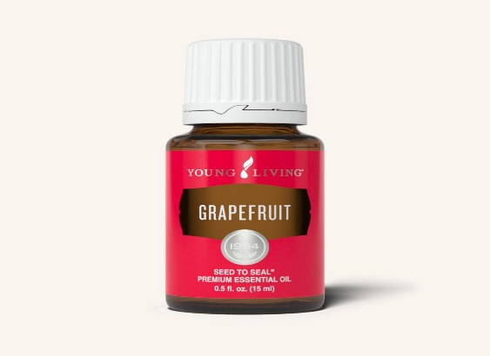

Grapefruit essential oil has a fresh, uplifting aroma and has cleansing properties. When taken internally, it supports healthy weight management, as well as the lymphatic and circulatory systems.*

- Add 1–2 drops of Grapefruit Vitality to a vegetarian gel capsule and take daily to support the lymphatic system, circulatory system, and healthy weight management.*
- Add 1–2 drops of Grapefruit Vitality to your sparkling water or NingXia Red® for a crisp and refreshing beverage*

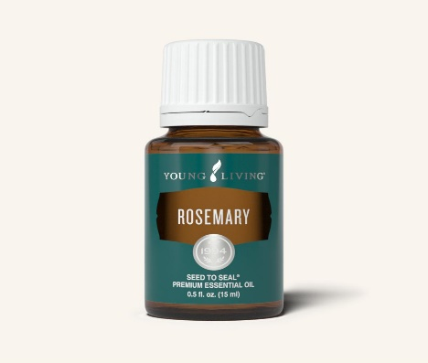
Rosemary Essential Oil

Rosemary Essential Oil supports overall well-being, contains antioxidents, and supports a healthy immune system.*

- Massage a few drops into your scalp or add Rosemary to your favorite shampoo or conditioner.

- Diffuse it during work, study, or homework time.

Add 1–2 drops of Rosemary Vitality to a vegetarian gel capsule and take as a dietary supplement for immune and general wellness support.*

- Add Rosemary Vitality to your favorite dressings, dips, and marinades to infuse them with its herbaceous flavor.

Eucalyptus Radiata

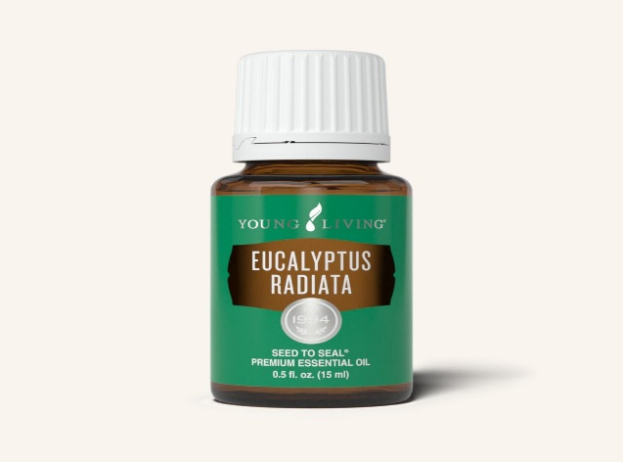
Eucalyptus Radiata essential oil contains eucalyptol, which provides a refreshing breathing experience with an camphoraceous aroma that refreshes any stuffy environment.
- Turn your shower into a spa by putting 5–10 drops of Eucalyptus Radiata on a warm, damp washcloth and placing it in the shower, just out of direct contact with the water before showering.
- Add 2–3 drops to Ortho Ease® massage oil and massage it into your feet or muscles after activity for a rejuvenating experience.
- Diffuse Eucalyptus Radiata in your home or work space for a clean, energizing aroma.
- Create a DIY room-refreshing spray with Eucalyptus Radiata to combat stale odors.

Registration is open for virtual Beauty School
Beauty School is coming to you live on February 9 from 10 a.m. to 2 p.m., MT. Join us for a deep dive into our ART®, Savvy Minerals®, and KidScents® lines; learn social media time-savers to expand your influence; and hear tried-and-true tips from successful brand partners. We’ll also show you how to whip up healthy einkorn treats for those busy days when you need a little extra energy. To join in on the fun, first customize your experience by selecting the ticket you want, then visit Young Living's Beauty School Facebook page on 9 to watch the event.

2022 February Beauty School
February 9, 2022 February
10:00 AM-2:00 PM
Trying to build a YL business with a swamped schedule? Beauty School can help! Join us on February 9 from 10 a.m. to 2 p.m., MT, for a day of pampering and empowerment. Learn shortcuts for marketing your business on social media, time-saving clean beauty tips, and successful strategies from brand partners who’ve been in your shoes.
During this event, we’ll teach you fun DIY projects—including a recipe for tasty einkorn energy bites—that you can use to share Young Living in an organic way.
You will also be the first to see our new and exclusive business-building tools. Look forward to fresh marketing visuals and handouts to help you grow your business and reach your goals. Plus, discover confidence-boosting scripts and suggestions that will streamline your presentations and assist the newbies on your team.
Ready to gain the steps, tools, and confidence to grow your YL business successfully? Sign up for February’s virtual Beauty School today!
Signature Registration $150
Beauty case, Beauty School Book, Amoressence™ EO, Headband, ART™ Light Moisturizer, ART™ Gentle Cleanser, ART™ Renewal Serum, Tummygize, Abundant Lipstick, Poppy Seed Scrub, and Swag. Sachets: Wolfberry Eye Cream (1), ART™ RefreshingToner(1), Hand purifier (1), NXR Packet (1), Mindwise (2), corporate presentation copies, certificate of attendance, and more ...
Premium Registration $50
Branded makeup bag, Amoressence essential oil blend, Full-size skincare or Savvy Minerals product, Sample-size skin care products, Headband, Swag, Printed copy of the corporate presentation, Certificate of attendance
Basic Registration $15
Sample-size skin care product, Swag, Printed copy of the corporate presentation, Certificate of attendance

Please double check your credit card that you have on file with Young Living as some are becoming expired with the new year. Also if you sign someone up make sure they put their address in correctly on the website.

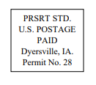
Lansing Essential Oils
3266 275th Street
Worthington, IA 52078
YL# 340519
December 2021
RETURN SERVICE REQUESTED

To receive future newsletters via email, please send us an email from the requesting address.
We will then add you to our email list. The email address is willylansing@gmail.com
Address Change—Please Print
Notify us via email: Lansingessentialoilsnewsletter@gmail.com, phone: 563-926-2534,
or mail: 3266 275th St. Worthington, IA 52078
Name: __________________________________________________________________
Address: ________________________________________________________________
City: ________________________________________State: ____________Zip: _______
Email: __________________________________________________________________ If you have a change of address or Email, please let Young Living know so they can update your information also.

