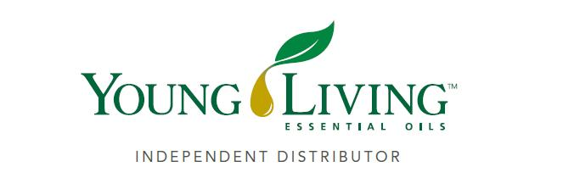
Lansing Essential Oils Newsletter
William Lansing
YL #340519
May 2022
3266 275th St, Worthington, IA 52078
563-926-2534
Lansingessentialoils.com
Lansingessentialoilsinc@gmail.com
Newsletter specific: Lansingessentialoilsnewsletter@gmail.com
We do not treat or diagnose. This newsletter is intended for informative purpose ONLY. If you have an illness or personal issue it is always best to consult your physician.


CLASSES:
Class will be held the first Thursday of every month at 6:30 PM at the Westminster Presbyterian Church- 2155 University Ave, Dubuque, IA

It’s Convention Time!!!!! June 15-18, 2022
If you haven’t signed up for the Convention you can do it by June 10 for the Virtual viewing. It should be a great week of information and products.

June Promos are:
300 PV – Retail $145.86 Citrus Fresh Vitality, Citronella, Kidscents Owie and receive the Viya Travel Diffuser free. The diffuser is spill-resistant reservoir and is compact in size. Place it in your cup holder or hotel room to transform your space into an essential oil oasis.

250 PV- Retail $107.04 Citrus Fresh Vitality, Citronella and receive Kidscents Owie for free. Place your qualifying order through Loyalty Rewards and you will also get Stress Away for free.

190PV-Retail Value $43.09 Receive Kidscents Owie for free.

100PV- Retail Value $10.00 Place 100+ PV loyalty order and receive 10 loyalty points to redeem for future product purchases.

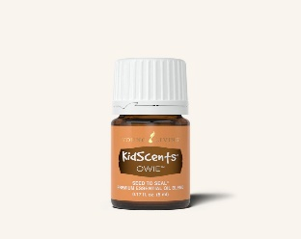
Kidscents Owie essential oil blend is a must have for outdoor play. This blend naturally soothes delicate skin with the help of Tea Tree, Elemi and Idaho Grand Fir essential oils. Keep a bottle on hand for kid-mergencies during park outings, bike rides or hiking just to mention a few.

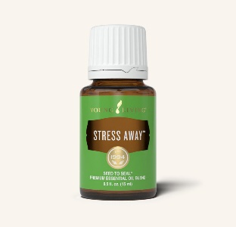
Stress Away is a vacation in a bottle. Satisfy your wonderlust when stuck at home by diffusing it soothing tropical scent. It is a blend of Lime, Copaiba, Lavender, Cedarwood and Vanilla.

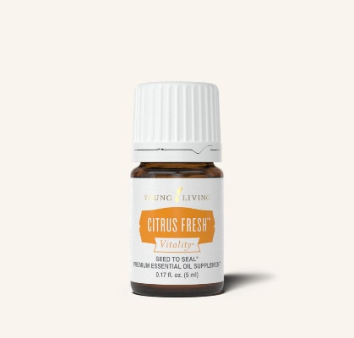
Citrus Fresh Vitality combines Grapefruit, Orange, Mandarin, Tangerine, Lemon and spearmint essential oils which contain antioxidants and provide cleansing properties when taken internally. Infuse your water with aburst of flavor by adding 2-3 drops o your glass during the day. Use it in recipes for fruit salads, salad dressings and marinades to enhance flavor.

Recipes
Guacomole

Ingredients:
2 Avocados
2 drops Citrus Fresh Vitality
1 drop Lime Vitality
1 Tbsp. fresh lime juice
1 clove garlic, minced
2 Tbsp. chopped red onion
1-2 Roma tomatoes, seeded and diced
1 Tbsp. chopped cilantro
Pinch of salt
Pinch of black pepper

Instructions:Remove the pit from the avocados and scoop the flesh into a bowl, mashing roughly with a fork. Add all other ingredients and stir until mixed. Garnish with cilantro and enjoy with torilla chips or with your favorite Mexican-inspired dishes.

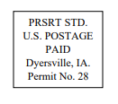
Lansing Essential Oils
3266 275th Street
Worthington, IA 52078
YL# 340519
May 2022
RETURN SERVICE REQUESTED

To receive future newsletters via email, please send us an email from the requesting address.
We will then add you to our email list. The email address is willylansing@gmail.com
Address Change—Please Print
Notify us via email: Lansingessentialoilsnewsletter@gmail.com, phone: 563-926-2534,
or mail: 3266 275th St. Worthington, IA 52078
Name: __________________________________________________________________
Address: ________________________________________________________________
City: ________________________________________State: ____________Zip: _______
Email: __________________________________________________________________ If you have a change of address or Email, please let Young Living know so they can update your information also.

