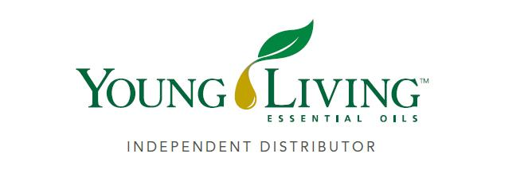

***Lansing Essential Oils INC. Newsletter***

***William Lansing***

***YL #340519***

**September 2025**

3266 275th St, Worthington, IA 52078

563-926-2534

Lansingessentialoils.com

[Lansingessentialoilsinc@gmail.com](mailto:Lansingessentialoilsinc@gmail.com)

**Newsletter specific:** [Lansingessentialoilsnewsletter@gmail.com](mailto:Lansingessentialoilsnewsletter@gmail.com)

***We do not treat or diagnose. This newsletter is intended for informative purpose ONLY. If you have an illness or personal issue it is always best to consult your physician.***

**CLASSES:**

**Y*oung Living Class will be held the first Thursday of every month at 6:30 PM at the Westminster Presbyterian Church- 2155 University Ave, Dubuque, IA***

**September Gifts with Purchase**

***You may be wrapping up your summer, but fall is calling! September’s gifts with purchase bring out the best of both seasons with cozy home scents to help as you ease into fall. With warm, spicy-scented Clove and Cinnamon Bark oils and yummy, immune-supporting Immugummies supplement, we’ll have you ready to step into autumn like you own it. Whether you’re savoring the last rays of summer or pulling out the sweaters, you’ll have everything you need to spice up your September.***

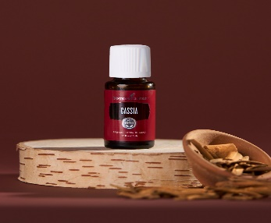**September Loyalty Order Offer**

Available exclusively for a limited time on loyalty orders through September: Cassia essential oil—a cinnamon-like addition to your lineup of fall aromas.

**Spend 100 PV**

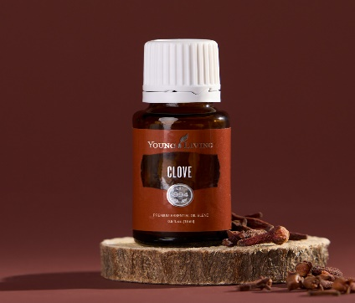**Clove essential oil, 15 ml**

**Retail value: $23.36**

Warm and spicy, Clove is the gateway oil to get you fall ready. It makes the perfect bridge from breezy summer nights to crisp autumn mornings. Mix it with V-6™ Vegetable Oil Complex for a warming massage and a calming aroma after a day out in the sun. Diffuse it for that crisp autumn aroma you crave. Adding Orange or Cinnamon Bark essential oil gives it that holiday-ready scent if you just can’t wait!

**Spend 200 PV**

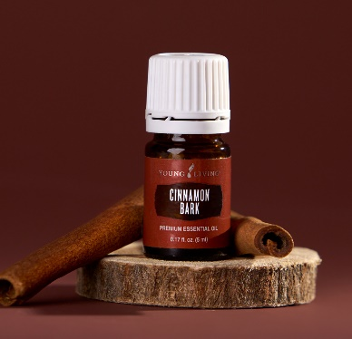**Cinnamon Bark essential oil, 5 ml**

**Retail value: $59.87**

Revel in instant fall feels with Cinnamon Bark oil’s bold, spicy-sweet scent. Banish stale air from your home by diffusing its warm aroma or mix it with your Thieves® Cleaner for a festive clean. As the summer warmth gives way to cooler days, Cinnamon Bark brings the right touch of spice to your season. Also receive Clove essential oil 15ml.

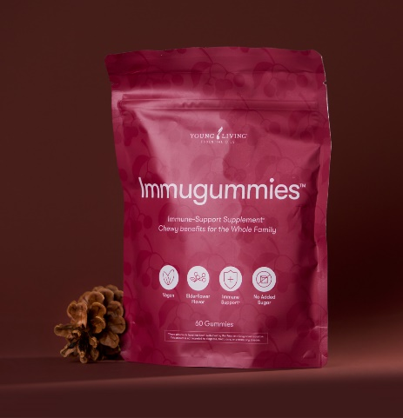**Spend 300 PV**

**ImmuGummies supplement**

**Retail value: $111.19**

That hectic back-to-school routine calls for added immune support. Immugummies help keep your wellness on track with powerful beta-glucans and delicious elderberry-lime flavoring, plus no added sugar. They’re made for busy fall days and loved by families on the go. Also includes Clove essential oil 15ml and Cinnamon bark essential oil ml.

**Diffuser recipes**

**Fall Frost Cozy Vibes**

3 drops Cinnamon Bark 4 drops Bergamot oil

3 drop Norther Lights Black Spruce 3 drops Lemon oil

3 drops Orange essential oil 3 drops Elemi oil

2 drops Wintergreen oil

**Diffuser blends for studying**

**Happy Homework** **Chalk Talk** **Elevate your Studies**

6 drops Hinoki oil 3 drops Orange oil 5 drops Bergamot oil

6 dops Sacred Frankincense oi 3 drops Rosemary oil 3 drops Lavender oil

4 drops Hong Kuai oil 2 drops Peppermint oil 2 drops Stress Away blend

3 drops Cedarwood oil