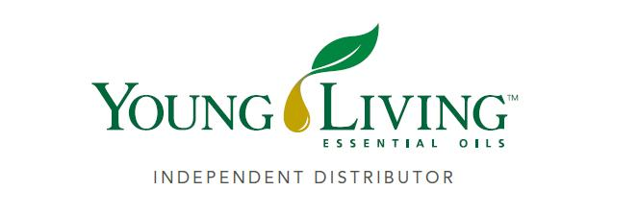

***Lansing Essential Oils INC. Newsletter***

***William Lansing***

***YL #340519***

**October 2025**

3266 275th St, Worthington, IA 52078

563-926-2534

Lansingessentialoils.com

[Lansingessentialoilsinc@gmail.com](mailto:Lansingessentialoilsinc@gmail.com)

**Newsletter specific:** [Lansingessentialoilsnewsletter@gmail.com](mailto:Lansingessentialoilsnewsletter@gmail.com)

***We do not treat or diagnose. This newsletter is intended for informative purpose ONLY. If you have an illness or personal issue it is always best to consult your physician.***

**CLASSES:**

**Y*oung Living Class will be held the first Thursday of every month at 6:30 PM at the Westminster Presbyterian Church- 2155 University Ave, Dubuque, IA***

**Cozy season, strong you. October’s free gifts with purchase support your immune system and a refreshing breathing experience—because fall feels even better when you feel your best. Scroll down to see what you’ll get free this month.**

**OCTOBER LOYALTY ORDER OFFER**

***15 percent off Red Cedar Bliss™ essential oil blend***

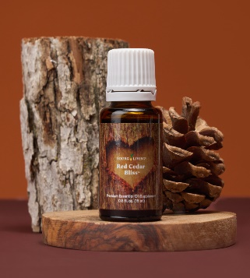

Wellness is bliss! Take Red Cedar Bliss essential oil blend internally to support a healthy immune system and a healthy you. You can also diffuse this blissful blend to let its notes of cozy spice, sweet citrus, and soft cedar whisk you away to a nice, quiet getaway.

**100 PV ORDER**

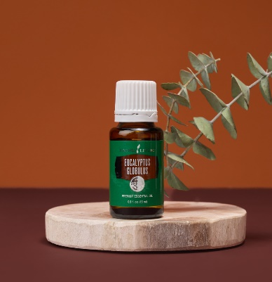**Loyalty order: Eucalyptus Globulus essential oil, 15 ml**

Retail value: $21.71

Breathe in fall freshness. With its crisp, invigorating aroma, Eucalyptus Globulus helps create a refreshing breathing experience and a soothing, spa-like atmosphere. Diffuse it on chilly nights, add it to your shower for a spa-like steam, or dilute and apply it to the upper back, chest, or under the nose.

**200 PV ORDER**

**Season Essentials™ essential oil blend, 15 ml**

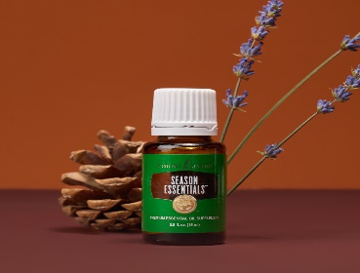Retail value: $77.63

Meet your season essential. This powerhouse blend of Lemon, Lavender, Peppermint, Goldenrod, and Eucalyptus Blue essential oils creates a crisp, minty aroma that refreshes stuffy environments during the colder months. Add a drop to a veggie capsule or teaspoon of honey and take internally to support a healthy respiratory system. Also includes Eucalyptus Globulus 15ml.

**300 PV ORDER**

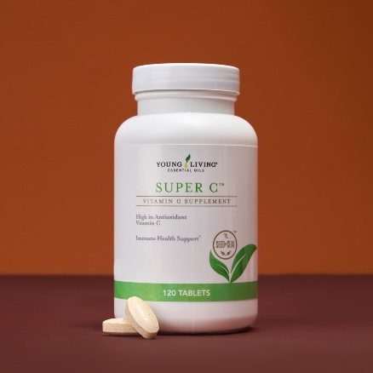**Super C™ tablets**

Retail value: $121.38

Stay strong all season long. Super C tablets deliver a big dose of vitamin C, plus zinc, manganese, and the antioxidant properties of four citrus essential oils. Take 2 tablets daily to support a healthy immune system, so you can enjoy every fall moment to the fullest. Also includes Eucalyptus Globulus 15ml and Seasons   
Essential oil 15ml.

**Diffuser Recipe**

**Changing Leaves**

6 drops Northern Lights Black Spruce

2 drops Wintergreen oil

2 drops Eucalyptus Globulus oil